**CHATBOT DEPLOYMENT WITH IBM CLOUD WATSON ASSISTANT**

**INTRODUCTION:**

The “Chatbot Deployment with IBM Cloud Watson Assistant for IT Helpdesk Assistant” project seeks to revolutionize IT support. By creating a chatbot using IBM Cloud Watson Assistant, it will efficiently address IT queries, troubleshoot technical problems, reset passwords securely, and offer guidance on device and software configurations. In today’s fast-paced digital landscape, the demand for efficient and accessible IT assistance is ever-increasing. This project seeks to develop a highly advanced chatbot tailored specifically for IT helpdesk support. This chatbot will become a virtual IT support companion, adept at handling a diverse array of technical inquiries, swiftly troubleshooting common issues, securely managing password resets, and providing expert guidance on configuring devices and software applications.

**PROBLEM DEFINITION AND DESIGN THINKING**

## Problem Statement:

## Create a helpful virtual guide using IBM Cloud Watson Assistant. Customize the chatbot to assist users on popular messaging platforms like Facebook Messenger and Slack. Provide useful information, answer FAQs, and offer a friendly conversational experience. Empower users with quick access to information and create meaningful connections through your virtual guide.

The objective of this project is to design, develop, and deploy a highly functional and user-friendly chatbot that can assist our customers, answer inquiries, and provide support across various digital platforms.

## Problem Definition:

## The project involves creating a chatbot using IBM Cloud Watson Assistant. The goal is to develop a virtual guide that assists users on messaging platforms like Facebook Messenger and Slack. The chatbot should provide helpful information, answer frequently asked questions (FAQs), and offer a friendly conversational experience. The project includes designing the chatbot's persona, configuring responses, integrating with messaging platforms, and ensuring a seamless user experience.

## Design Thinking:

Design thinking is a user-centered approach to problem-solving and innovation. When applying design thinking principles to chatbot deployment, the focus is on creating a chatbot that not only functions well but also meets the needs and expectations of its users.

**Empathize: Understand User Needs and Goals**

* Conduct user research to gain insights into the needs, behaviors, and pain points of potential chatbot users.
* Create user personas and customer journey maps to visualize the user experience.
* Gather feedback from existing customer support channels to identify common issues and questions.

1. **Define: Frame the Problem and Set Objectives**

* Clearly define the problem you aim to solve with the chatbot.
* Set clear objectives and success criteria for the chatbot deployment.
* Identify user scenarios where the chatbot can add value, such as answering FAQs, providing product information, or troubleshooting common issues.

**3. Ideate: Generate Creative Solutions**

* Brainstorm potential chatbot features and capabilities that align with user needs and business goals.
* Encourage cross-functional collaboration among designers,

developers, subject matter experts, and customer support teams to generate ideas.

* Explore different conversational flows and dialogue design options.

**4. Prototype: Create a Chatbot Prototype**

* Develop a functional prototype of the chatbot to visualize how it will work and interact with users.
* Use prototyping tools to design the chatbot's user interface and conversation flows.
* Conduct usability testing with a small group of users to gather early feedback and identify areas for improvement.

**5. Test: Gather User Feedback**

* Launch a pilot version of the chatbot to a select group of users or within a controlled environment.
* Collect feedback from users about their experience with the chatbot.
* Analyze user interactions, conversation logs, and user satisfaction to refine the chatbot's design and functionality.

**6. Implement: Develop and Deploy the Chatbot**

* Based on the feedback and insights gathered during testing, refine the chatbot's design, dialogues, and user interface.
* Collaborate with developers to build and configure the chatbot on the chosen deployment platform (e.g., website, messaging app,etc).
* Ensure that data security and privacy measures are in place, including compliance with relevant regulations.

**7. Iterate: Continuous Improvement**

* Monitor the chatbot's performance and gather ongoing user feedback after deployment.
* Use analytics to track KPIs and identify areas where the chatbot can be enhanced.
* Implement regular updates and improvements to the chatbot based on user insights and changing business needs.

**8. Scale: Expand Usage and Reach**

* As the chatbot proves its value, consider expanding its availability to a broader user base and across additional platforms.
* Prepare for scalability by optimizing infrastructure and resources to handle increased user interactions.

By following this design thinking framework, we can create a chatbot deployment to deliver a valuable and satisfying user experience.

**INNOVATION DESIGN TO SOLVE THE PROBLEM**

**PROJECT OBJECTIVES:**

The installation of Windows OS is generally a straightforward process, but like any software installation, it's not immune to errors. There are some of the potential errors that users may encounter during the installation of Windows OS.

The main objective is to ensure :

Smooth Process

Minimize errors

Provide Clear Instructions

Offer Troubleshooting Guidance

Assist with Partitioning

Suggest Best Practices

**INNOVATION IDEAS:**

* 1. Disk-related errors:

Such as problems with partitioning, formatting, or selecting the correct disk for installation.

* 1. File copying errors:

Issues with copying files from the installation media to the hard drive during the installation process.

* 1. Hardware compatibility issues:

Problems arising due to incompatible or faulty hardware components.

* 1. Installation process interruption:

Unexpected interruptions during the installation, which can cause corruption or incomplete setup.

* 1. Driver issues:

Failure to install necessary drivers for components like graphics cards, network adapters, etc., causing functionality problems.

* 1. Activation errors:

Difficulties in activating Windows due to issues with product keys or activation servers.

* 1. User account creation issues:

Problems creating or setting up user accounts during the installation process.

* 1. Network configuration problems:

Difficulty in configuring network settings, causing connectivity issues post-installation.

**DESIGN:**

1.Development of the Chatbot:

Developers design and build the chatbot using the IBM Watson Assistant platform. This involves defining intents, entities, and dialog flows to enable the chatbot to understand user inputs and respond appropriately.

2.Training the Chatbot:

The chatbot is trained using sample conversations and data to improve its understanding of user queries and enhance its ability to provide accurate responses.

3. Integration with IBM Cloud:

Once the chatbot is developed and trained, it needs to be integrated with the IBM Cloud platform. This involves configuring the necessary settings, APIs, and connections to ensure seamless communication between the chatbot and other services on the IBM Cloud.

4. Deployment Configuration:

Developers configure deployment settings, such as deciding where the chatbot will be deployed, whether it will be embedded in a website, integrated with a mobile app, or used in a standalone environment.

5. Security and Access Control:

Implementing security measures to protect user data and ensure secure communication. Access control mechanisms are set up to manage who can interact with the chatbot and what actions they are allowed to perform.

6. Testing:

Thorough testing is conducted to identify and rectify any issues in the chatbot's behavior. This includes functional testing, user experience testing, and addressing any potential performance issues.

7. Scalability Considerations:

Assessing the scalability of the chatbot deployment to ensure it can handle varying levels of user interactions and requests. This may involve configuring resources on the IBM Cloud platform to accommodate increased traffic.

8. Monitoring and Analytics:

Implementing monitoring tools to track the chatbot's performance, detect errors, and gather analytics on user interactions. This data can be used to continuously improve the chatbot's capabilities.

9. Continuous Improvement:

Regularly updating and refining the chatbot based on user feedback, changing requirements, and evolving business needs. IBM Watson Assistant provides tools for ongoing training and improvement of the chatbot's language understanding.

**DEVELOPMENT PART 1:**

In IBM Watson assistant, which is a cloud based conversational AI platform, entities, intents and dialogs are key components used to build and train chatbots or virtual assistants

Now we are going to create the chatbot for that we will do the primary steps now.

**STEP 1**

Login To the IBM account and click on the Catalog and then search for Watson Assistant and give enter.

You will get the Watson Assistant There By default you will have this

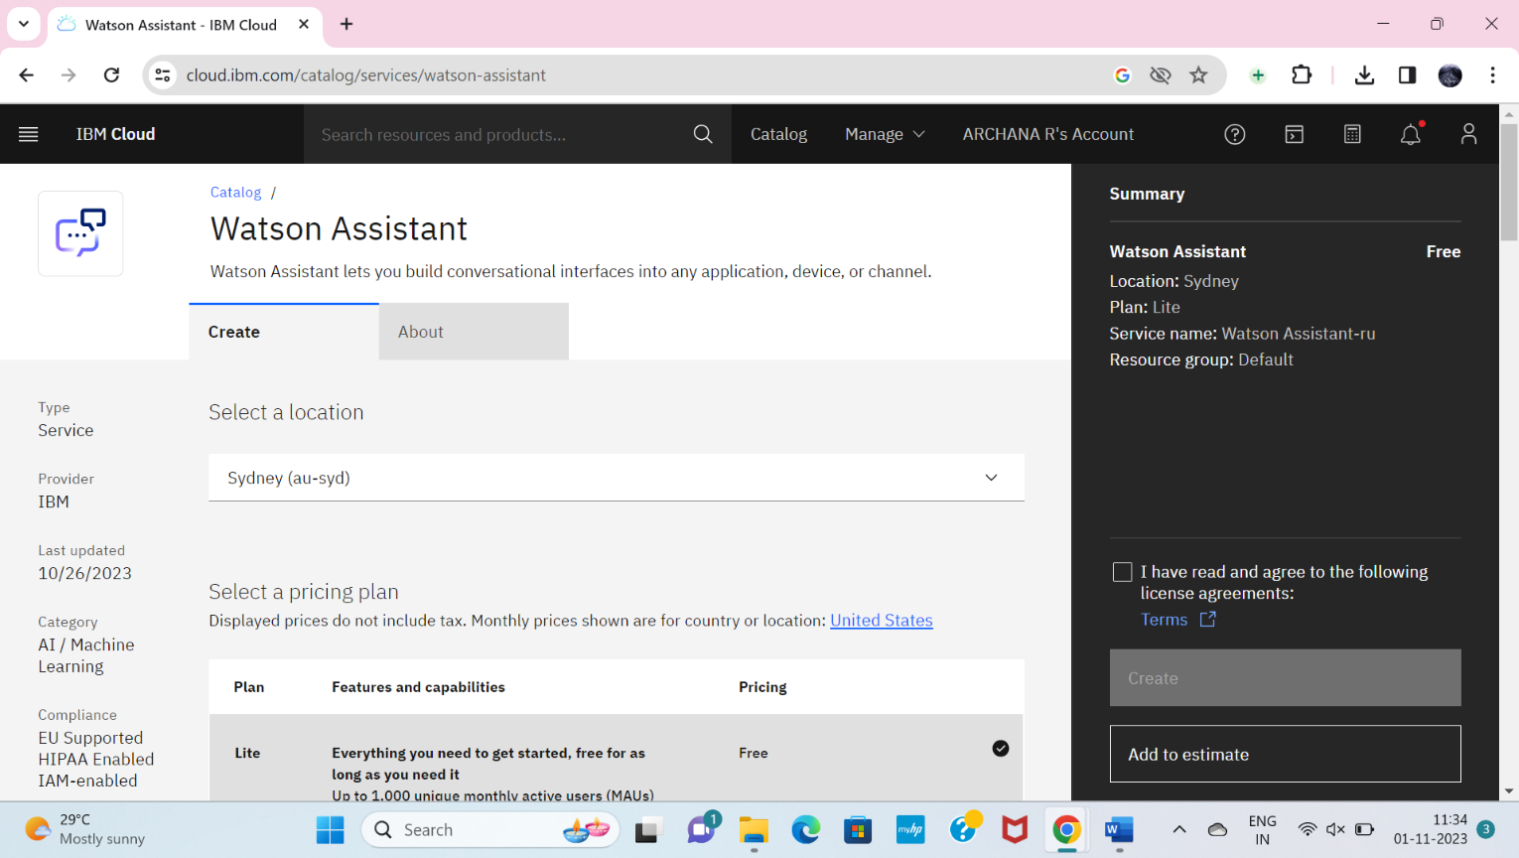

Change the default location and give your location and select the plan as Lite. Now click on create it will create an instance for you.

**STEP 2**

After creating an instance for Watson Assistant you need to launch the Watson Assistant by clicking the launch the assistant.

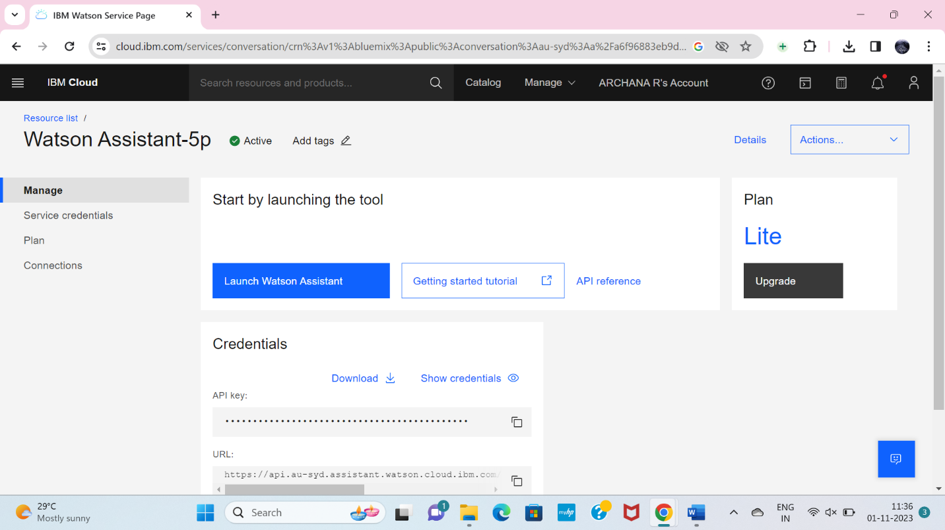

**STEP 3**

* It will give the access to create the assistant give the name for the Assistant and give the description for that assistant it's completely optional click on create and save it.
* Here I have been created BUGBUSTER BOT as my chat bot assistant name.

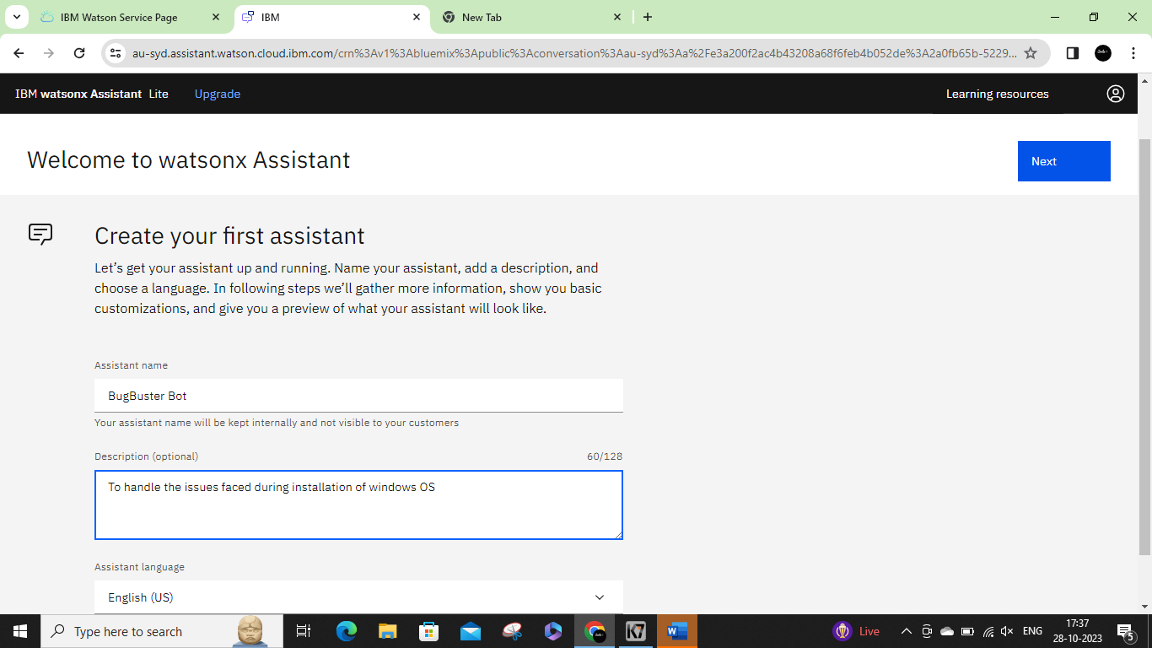

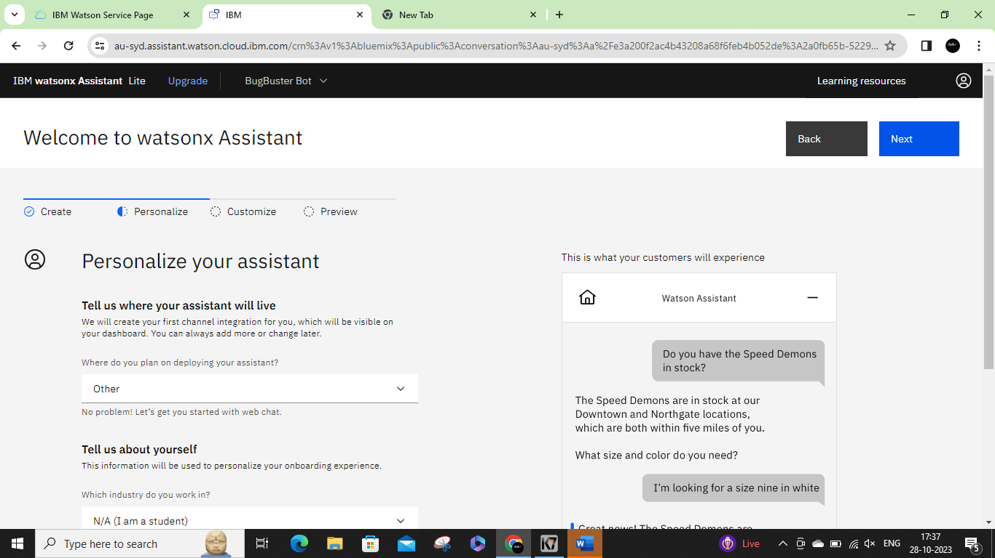

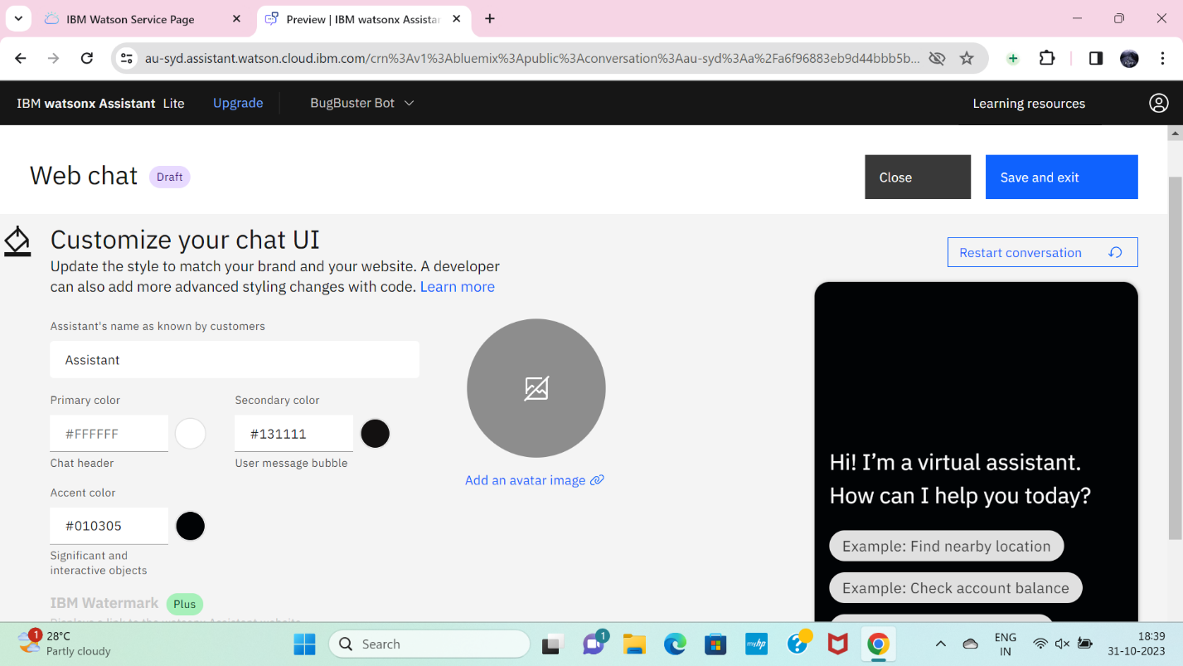

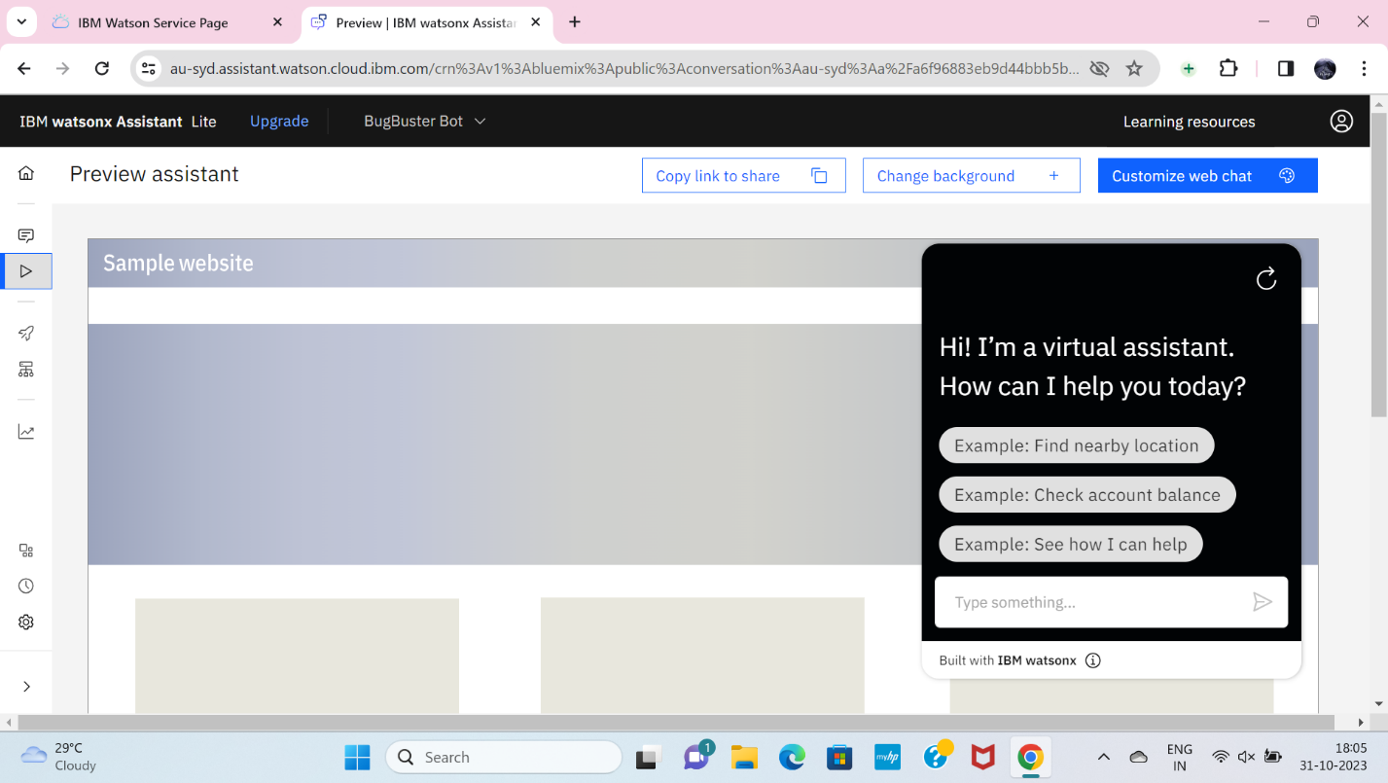

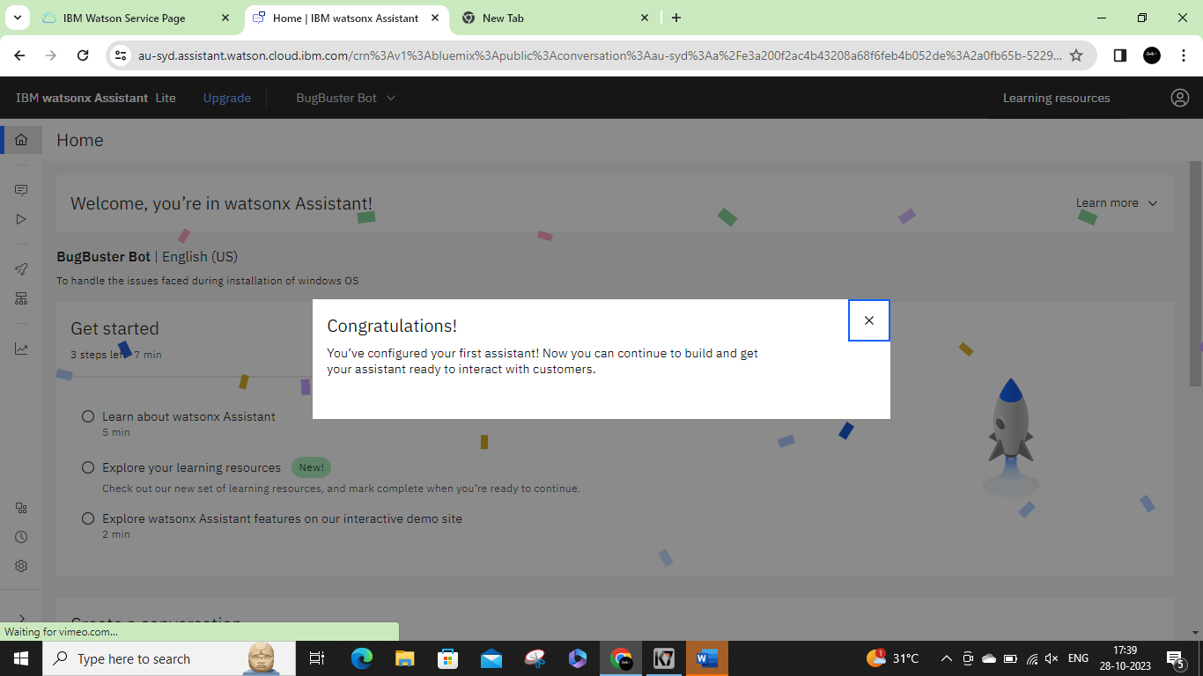

**STEP 4**

In the assistant settings, scroll down and then activate the dialog.

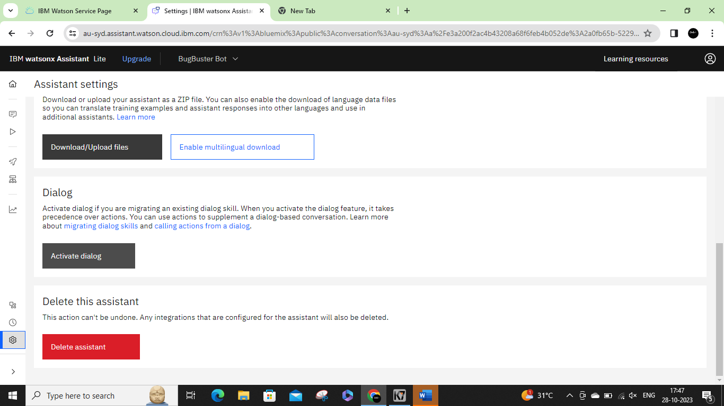

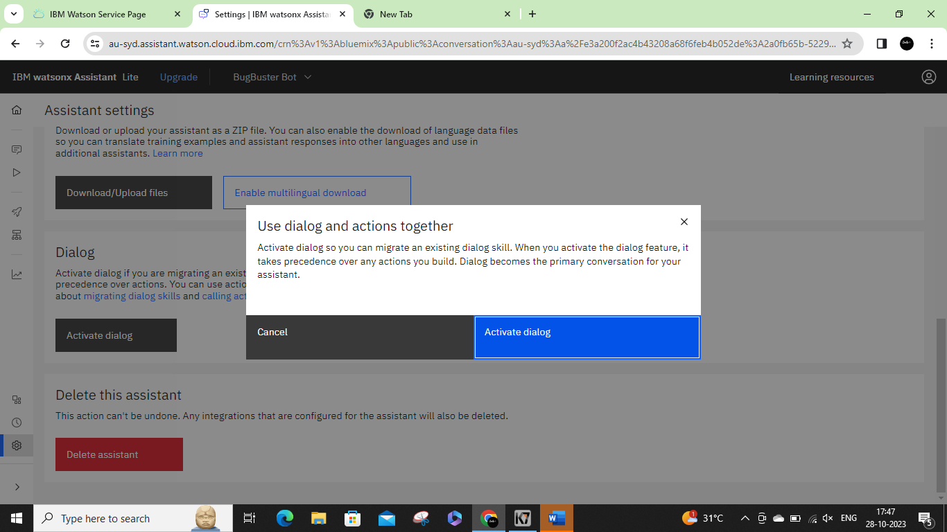

**STEP 5**

After activating the Dialog, you will get the Intents, Entities, Dialog, and Content catalog like shown below

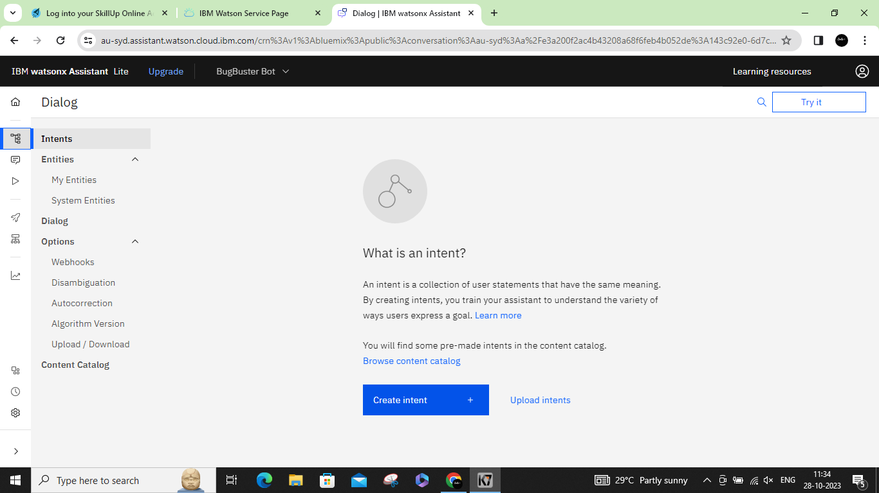

**STEP 6**

Create the intents

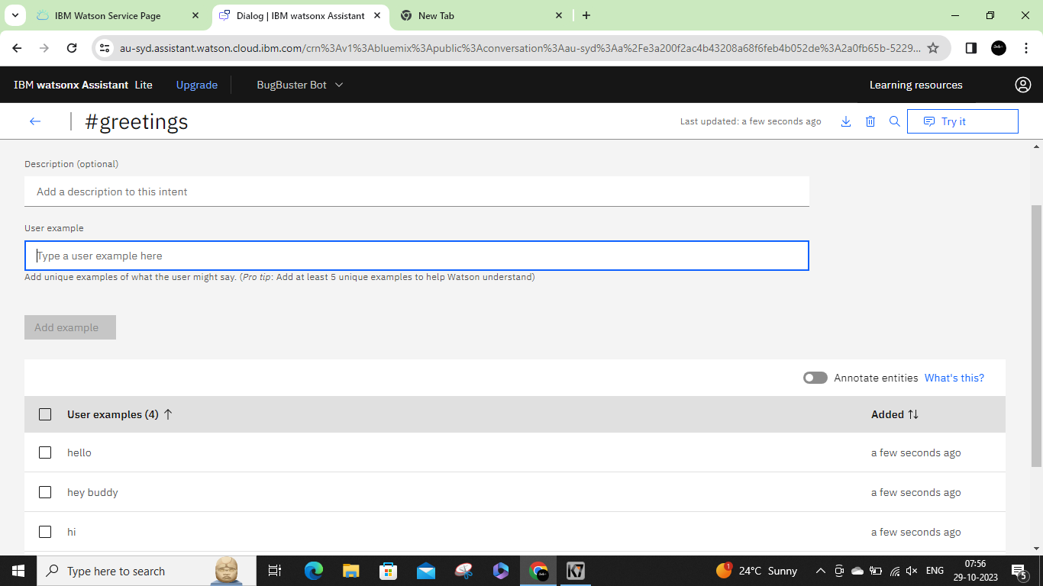

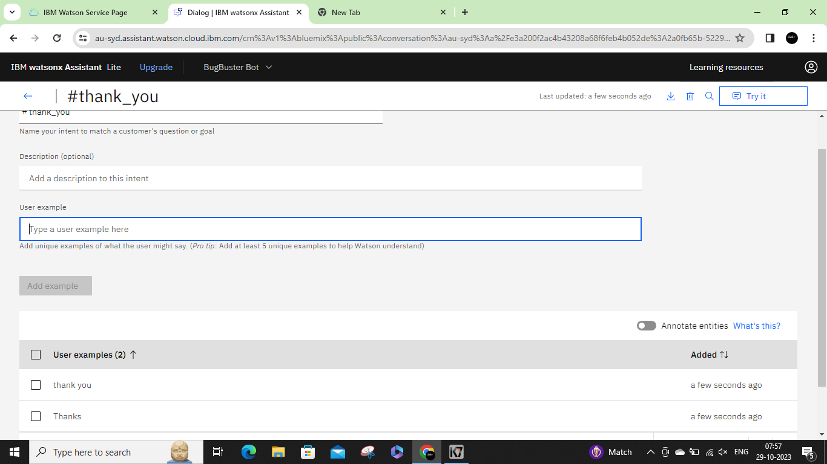

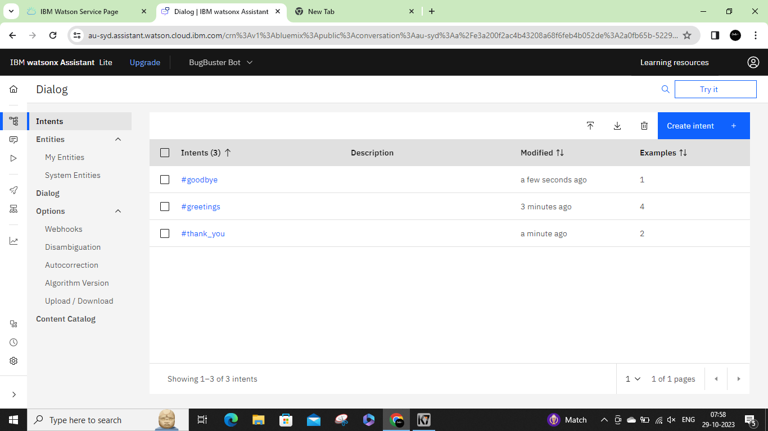

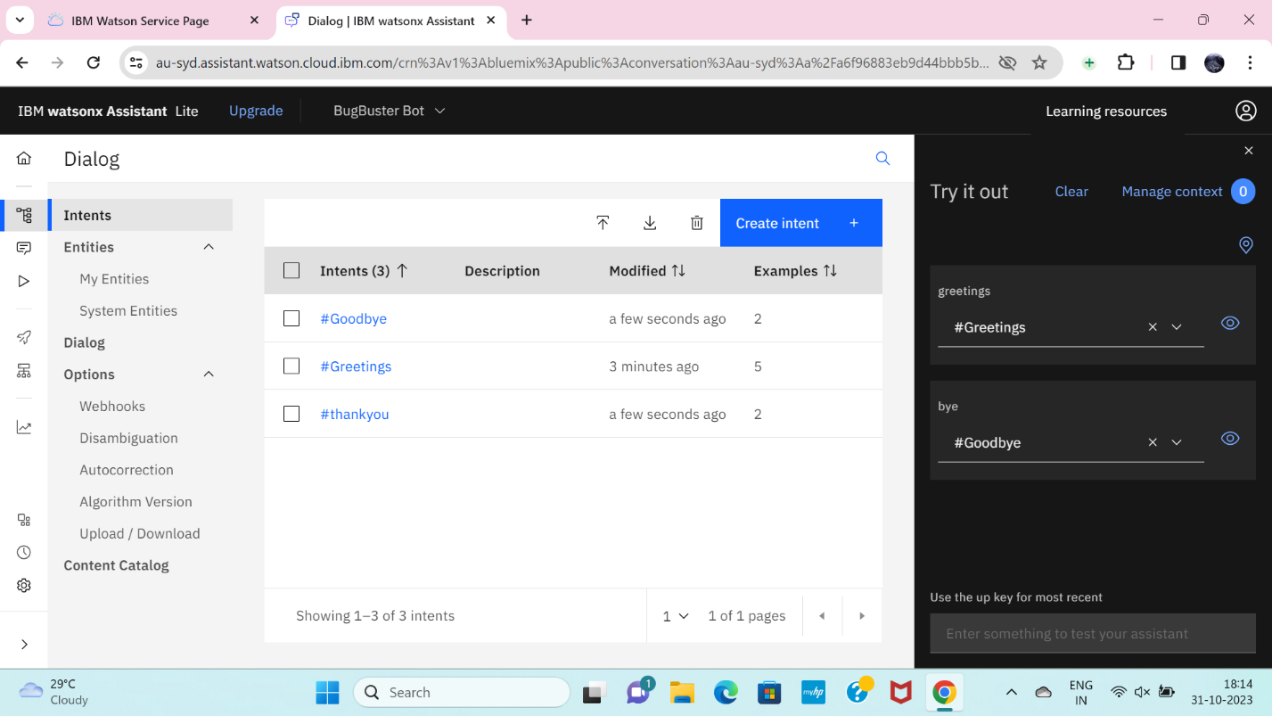

**STEP 7**

Create the Entities first and one variables for the entities you have been created.

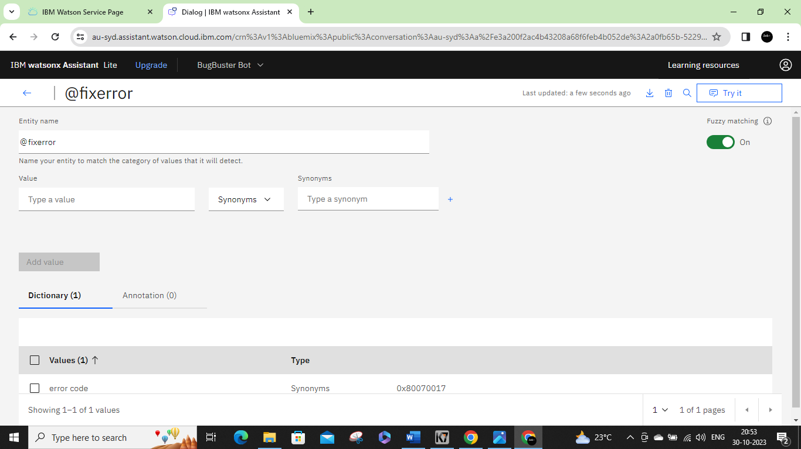

**STEP 8**

Next open the Dialog and then add nodes for all the Intents you have created where we need to give the responses for the selected queries. Whereby default we will have Anything else node.

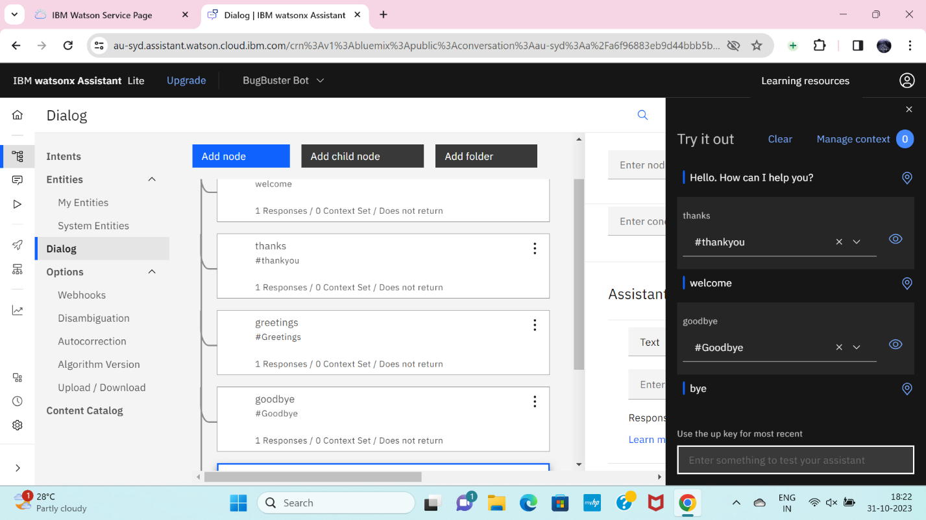

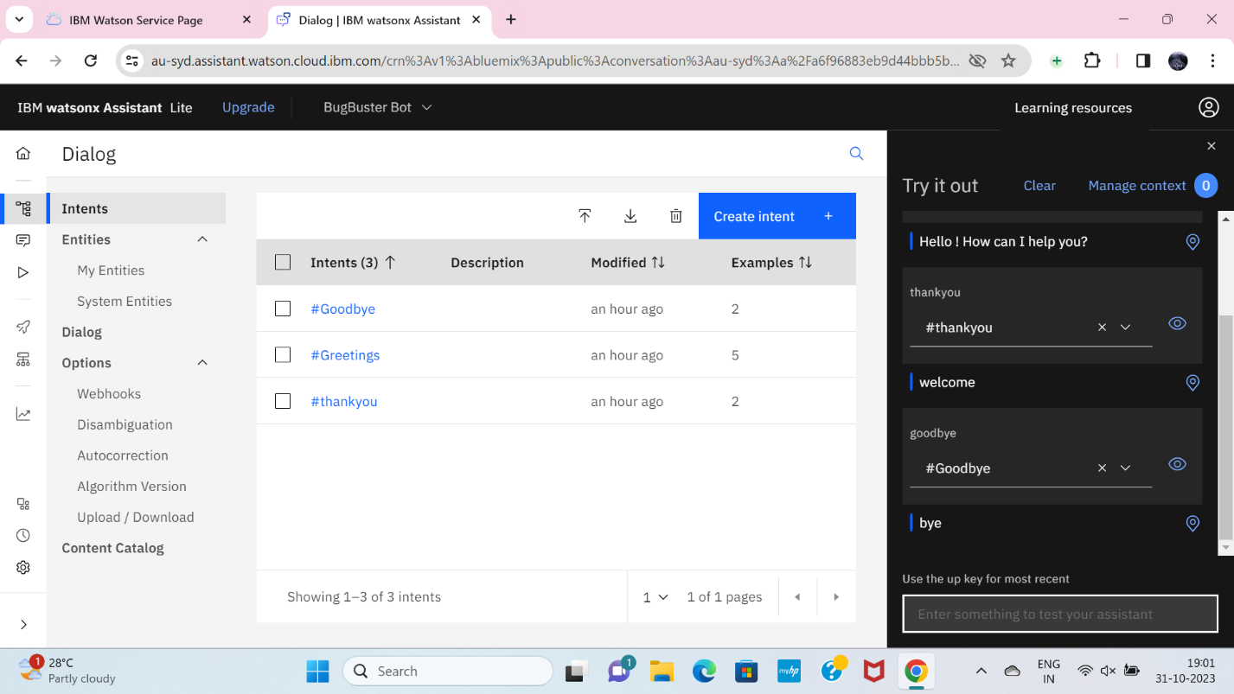

**STEP 9**

Create conversational flow

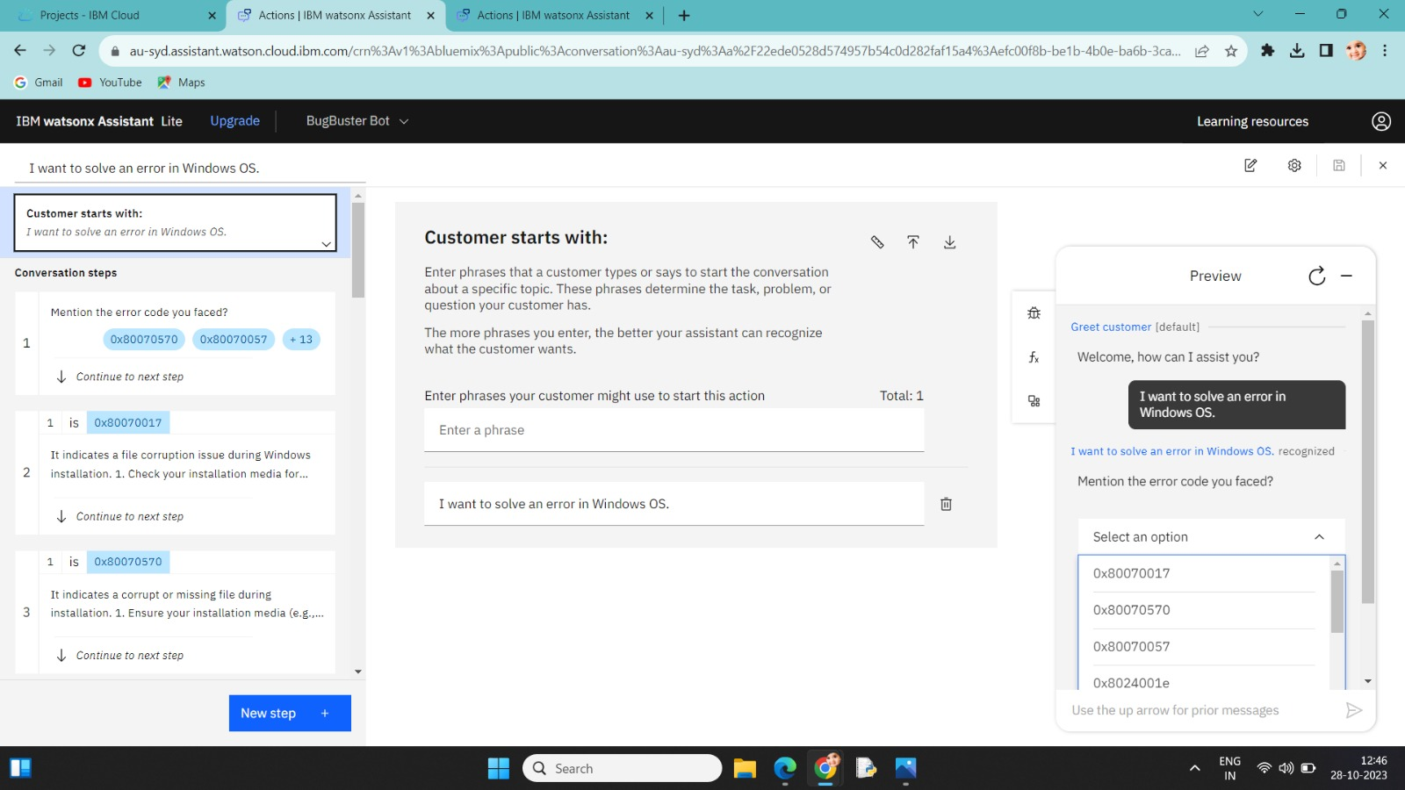

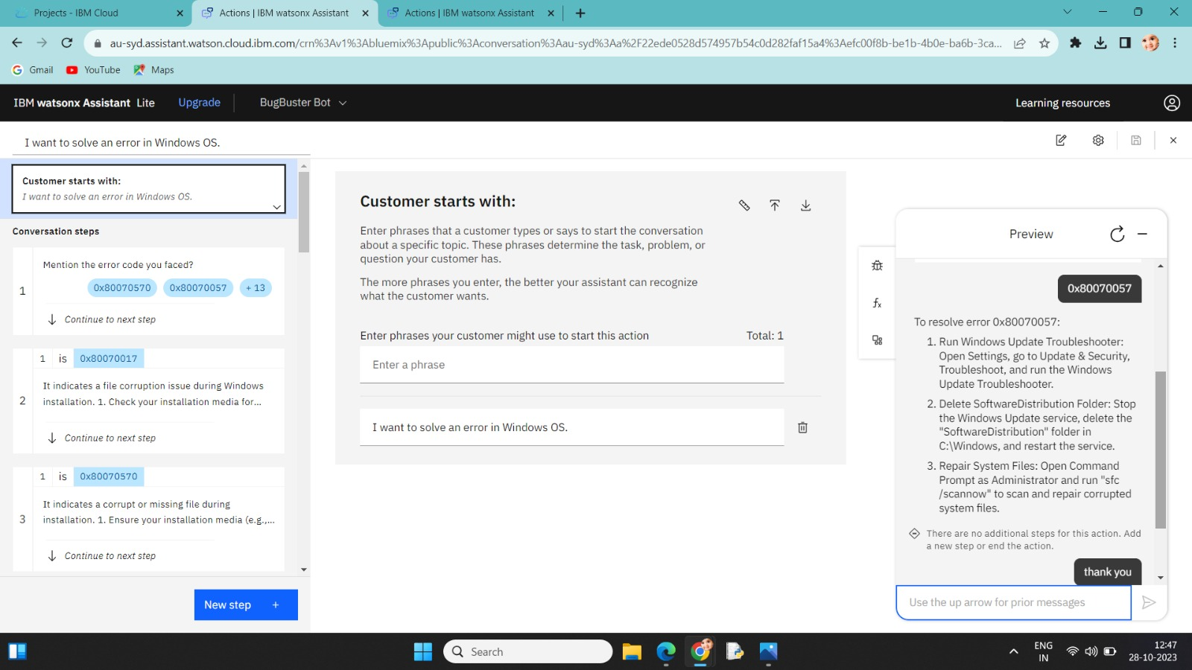

**DEVELOPMENT PART 2:**

Integrating the chatbot with Facebook Messenger and Slack using respective APIs.

Initially go to IBM and login and then go to the already existing Watson instance and then open it and launch the assistance. It shows already existence bot that we created in the before phase open the home page in it and then start connecting the channels.

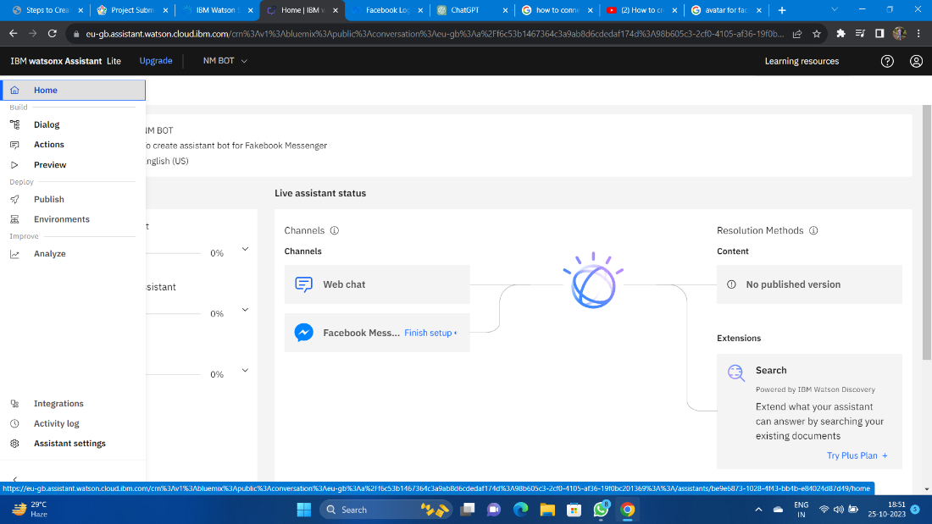

**Step 1:** Create a Facebook Page and log in to your Facebook account.

Go to Facebook's Create a Page and follow the steps to create a Facebook Page. This Page will be used to host your chatbot.

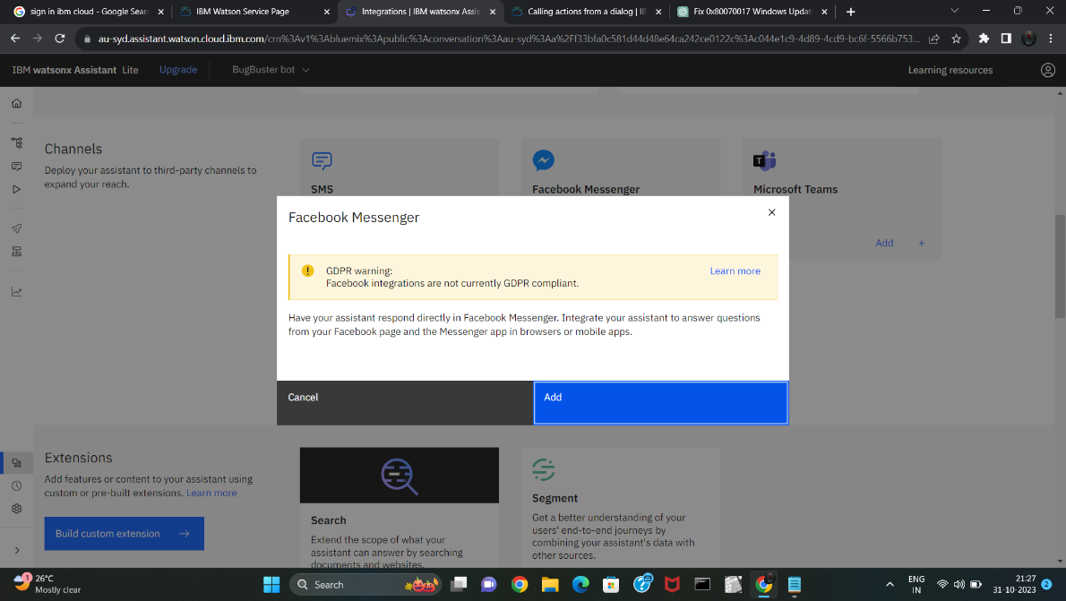

**Step 2:** Set Up a Facebook App

Go to the Facebook for Developers website.

Create a new app by clicking on "My Apps" and then "Create App."

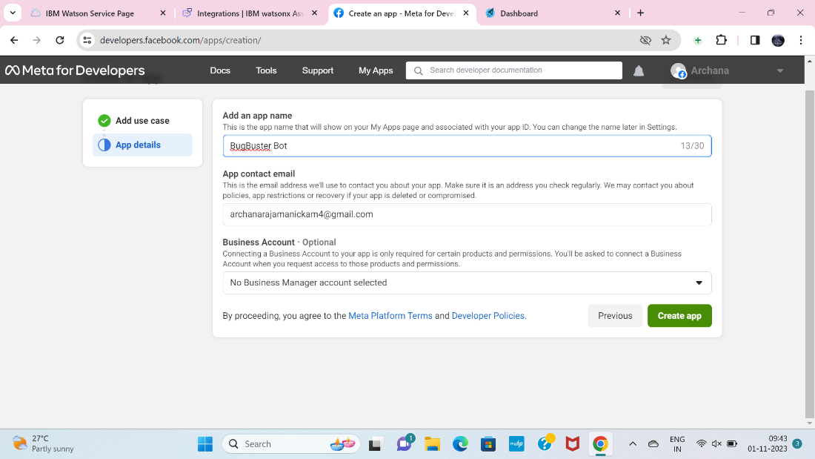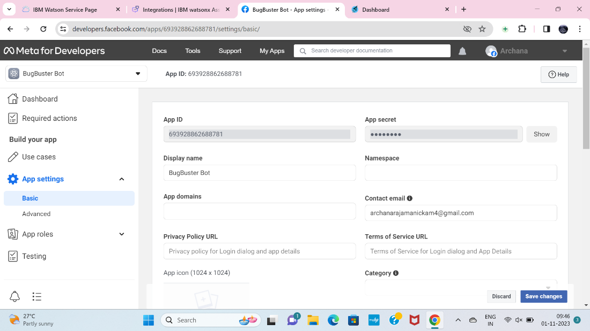

**Step 3:** Configure the Facebook App for Messenger

In your Facebook App dashboard:

a. Go to the "Messenger" section.

b. Under "Access Tokens," generate a Page Access Token. You'll need this token to connect your Watson Assistant to Facebook Messenger.

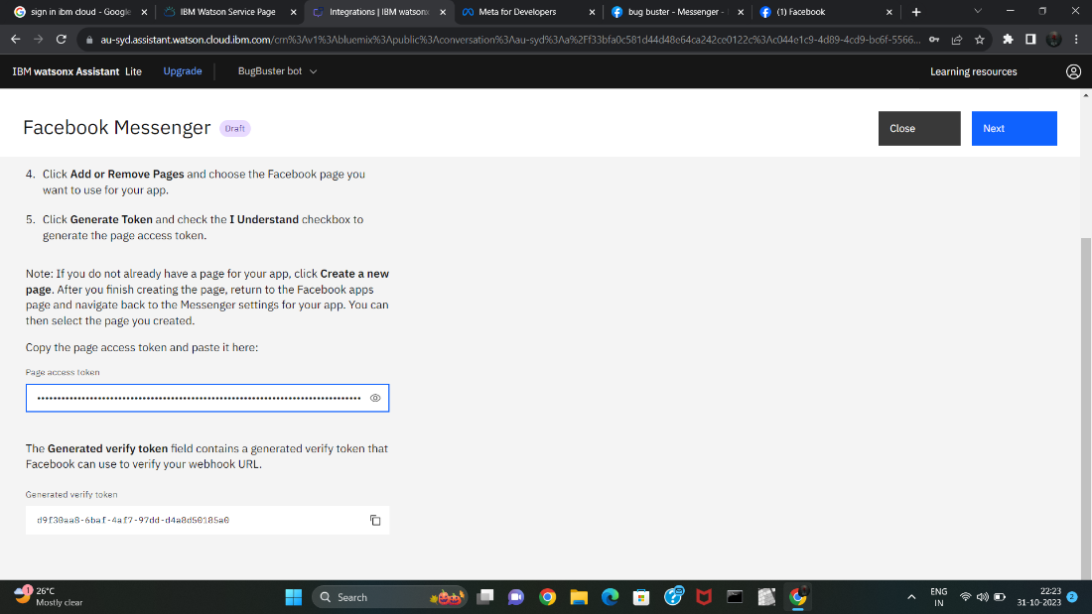

**Step 4:** Create or Access IBM Watson Assistant

If you don't have an instance of IBM Watson Assistant, you can create one on the IBM Cloud.

**Step 5:** Configure Watson Assistant

In your IBM Watson Assistant instance:

a. Create a new assistant or use an existing one.

b. Configure your assistant by adding intents, entities, and dialog flows that suit your chatbot's purpose.

(Note: Step4 and Step5 already completed in phase 3 )

**Step 6:** Integrate Watson Assistant with Facebook Messenger

In the Watson Assistant Dashboard:

a. Go to the "Skills" section.

b. Add a new skill or use an existing one.

c. In the skill settings, go to the "Integrations" tab.

d. Click on "Facebook Messenger."

**Step 7:** Set Up the Webhook

In the Watson Assistant integration settings for Facebook Messenger:

a. Enter the Facebook Page Access Token you obtained in Step 3.

b. Specify the Webhook URL. This URL should be the same as the callback URL you set up in the Facebook App's Webhook settings.

c. Save the changes.

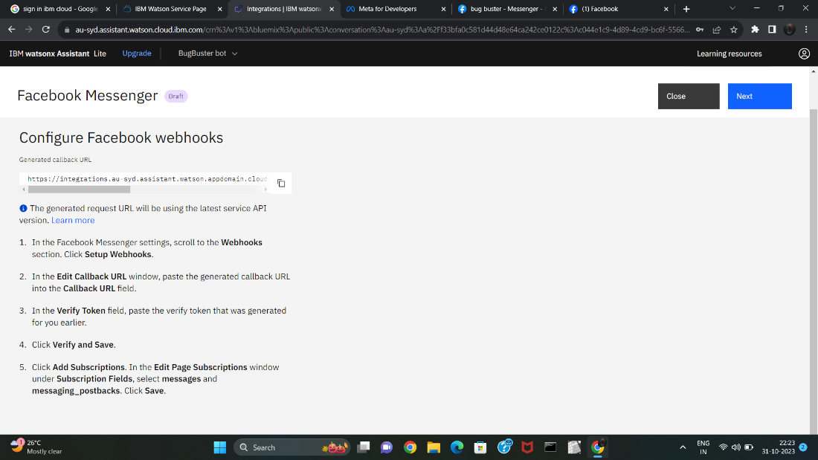

Step 8: Subscribe to the Facebook Webhook

In the Facebook App settings:

a. In the "Webhooks" section, click on "Edit Subscription."

b. Select the Facebook Page you created in Step 1.

c. Subscribe your Page to the webhook events.

After competing all the steps complete it and click finish t he connection now your bot is connected with the face book messenger .

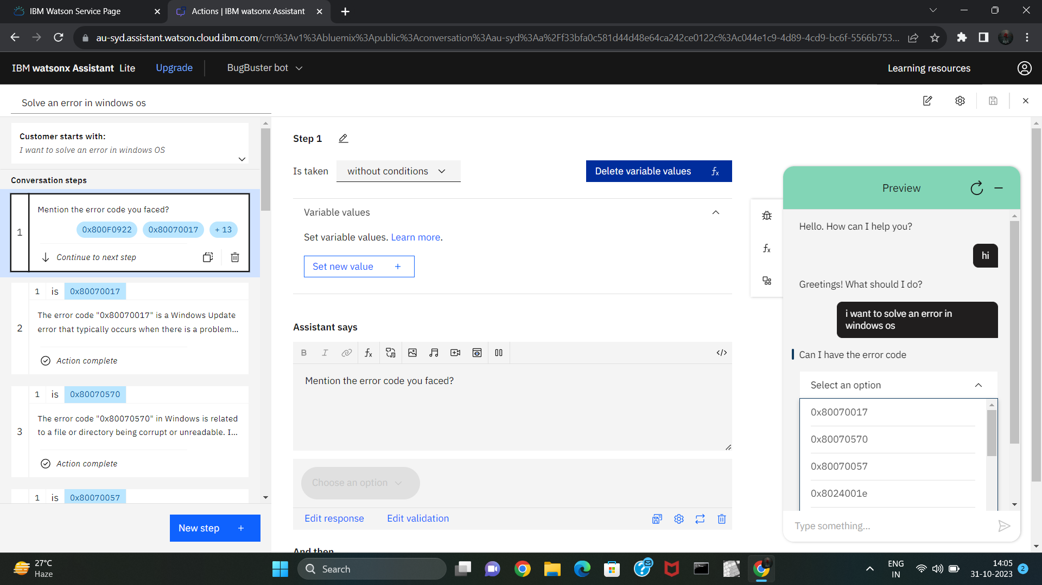

The implementation will work in the Facebooks messenger where and which the queries that has been mentioned in the entities, dialogs and interns will be given as reply in my messenger.

**CONCLUSION:**

By following these steps, We can successfully deploy a chatbot built with IBM Cloud Watson Assistant, providing an intelligent and interactive interface for users in various applications.